GREG: R OUTPUT AND COMMENTARY FOR FINAL PROJECT

RANDOM FORESTS

Combined data:

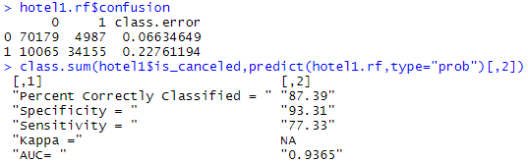

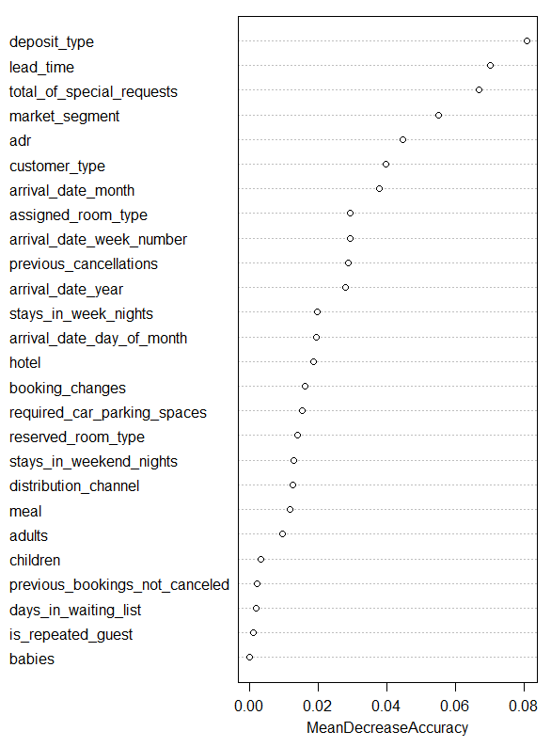

7-variable model:

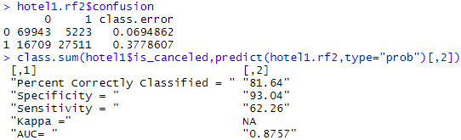

4-variable model:

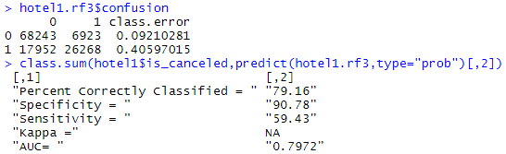

Partial Dependence Plots:

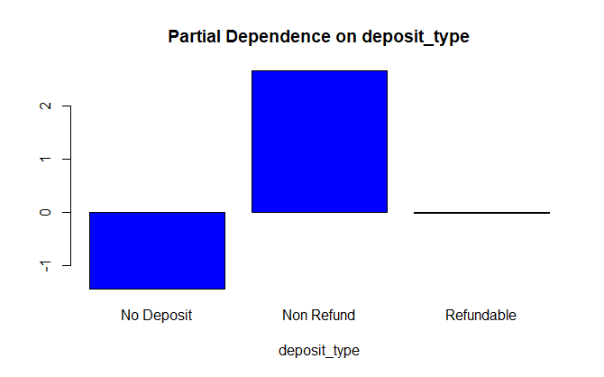

City Hotel:

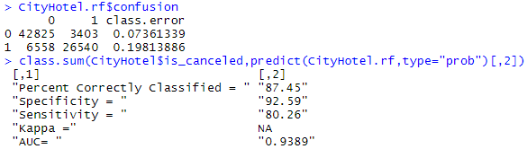

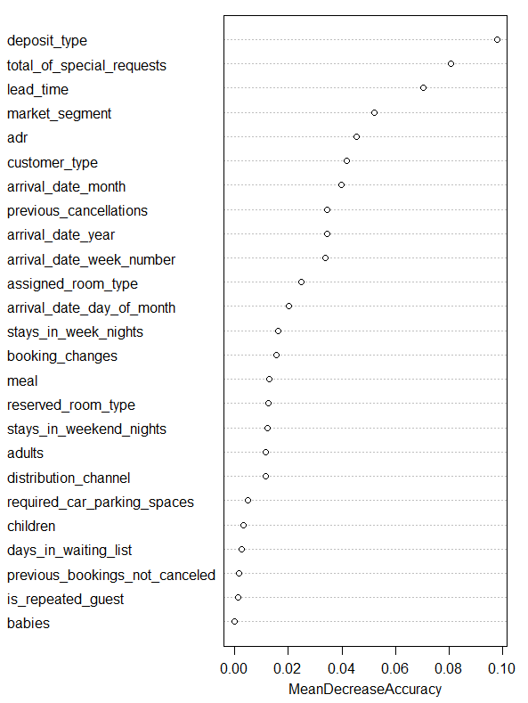

Resort Hotel:

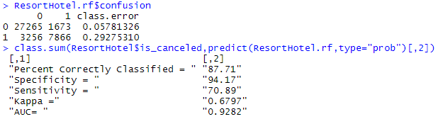

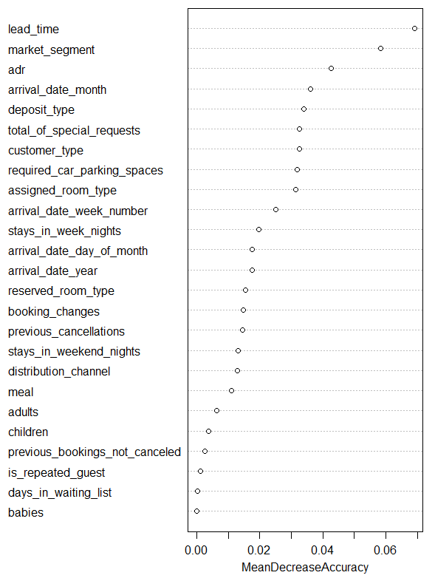

Out-of-Bag Confusion matrix for RF with HOTEL as Response

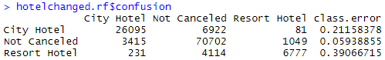

ADABOOST RESULT:

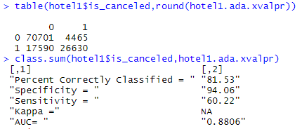

CLASSIFICATION TREES

Combined Data, 5 splits

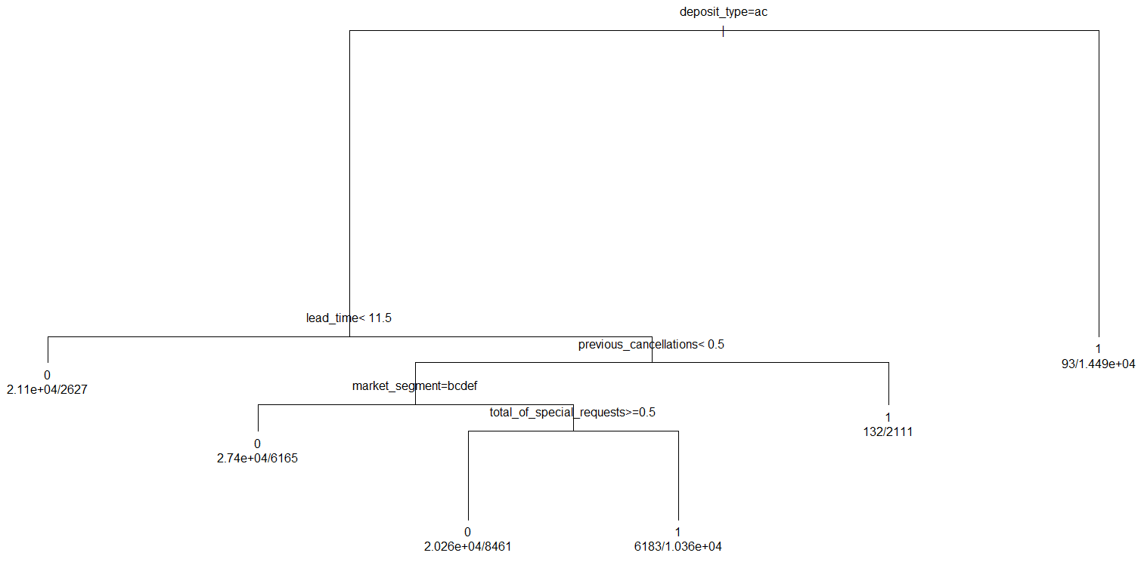

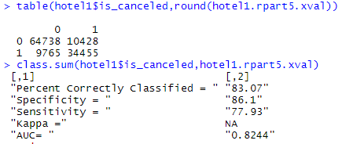

Resort Hotel only, 7 splits

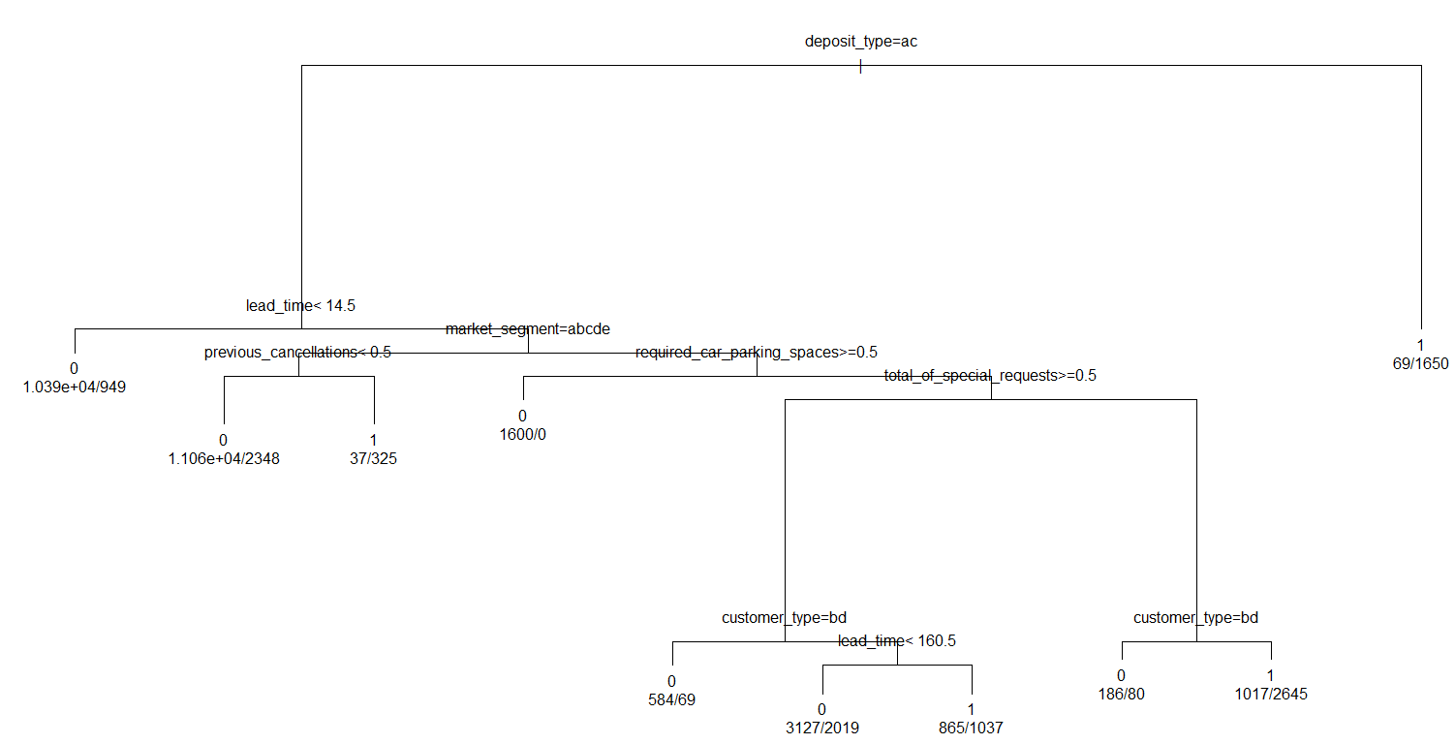

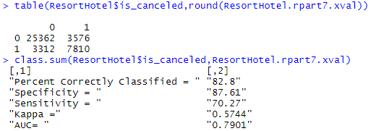

City Hotel Only, 6 Splits

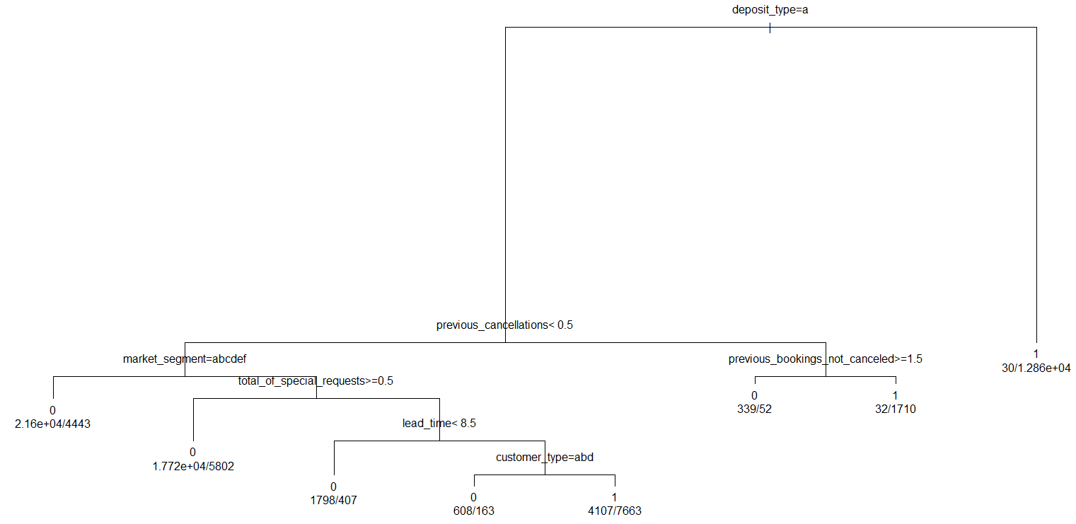

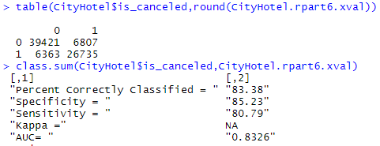

CROSSVALIDATED CONFUSION MATRIX FOR HOTEL AS RESPONSE